NOTE: Make sure to submit all required documents: 1. final paper (doc & pdf files), 2. completed registration form, 3. Payment Voucher to inquiry@icdmkd.org(Mail Subject: Paper ID + Registration).
2024 International Conference on Data Mining and Knowledge Discovery (DMKD 2024)
Jun.7-9 | www.icdmkd.org
- ATTENDEE INFORMATION
*Full Name: | 1-inch-Photo here
*Position√: Prof. Assoc. Prof. Asst. Prof. Dr. Mr. Ms.
*Affiliation & Nation:
*Email:
*Mobile Phone:
*Alternative Liaison (Name & Mobile):
Address& Zip Code (for post use):

- PAPER INFORMATION
*Paper ID: *Paper Pages: *Extra Page(>7 pages):
*Paper Title:
*Authors:
*Presentation Type√: Oral (15 mins) Poster (5 mins) Video (15 mins)
*Participation Certificate√: Softcopy Hardcopy I do not need the certificate
Student ID No. (student only):
IASED Member No. (member only):
* Receipt Issued to:

- PRICE INFORMATION

Category | Regular Registration | Your Choice
Full Paper Registration | 350 USD
Abstract Registration | 170 USD
Listener\Co-Author | 120 USD

Others
Additional Page | 50 USD
Printed Conference Proceeding | 60 USD

Notice
*If the paper exceeds 7 pages, the additional pages will be charged. The recommended general length limit is 5-14 pages per paper, and no less than 4 pages.
*All papers will be published online.
*For "No shows", registration fee is nonrefundable.
*Shall the conference is delayed or prevented (directly or indirectly) by the reasons of natural disasters, war, strike(s), epidemic or any other events which could not be controlled, the organizing committee shall be under no liabilities. The organizing committee reserves the right to change the conference date, venue or form of the conference (online or on-site)
*Cancellation policy: Applicant should send the refund/cancellation requests to inquiry@icdmkd.org. (The Cancellation policy are available in the official website of the DMKD 2024: www.icdmkd.org)
*Our payment system will not charge any extra fee, but the credit card payment may incur currency exchange charge which is charged by payers' bank, it should be borne by payers.
*One day program fee covers: Attend meeting sessions on June 8. Only do a presentation (without publishing any papers).
*Full registration fee for conference covers (Onsite Author only): publication fee + meeting sessions on June 8.

- PAYMENT INFORMATION
Online Payment linkage
http://meeting.yizhifubj.com/web/main.action?meetingId=351
E-mail: | Confirmation Number:
* VISA /Master cards are recommended payment methods. We will not charge any handling fees, please calculate the amount before you finish the payment.  * Please fill your E-mail address used for payment and Confirmation Number you received after paying.  * As the system will intercept the email address for multiple payments, it is recommended to use different email for each payment  *Please make sure the conference organizer, IASED’s logo is always appear on the page until you click “Pay”. Then you will be directed to payment page. | 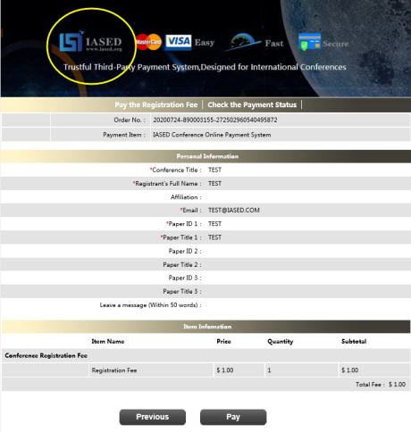
- IASED MEMBER APPLICATION
Join IASED now to quality for member registration rates. Please compile and return the Membership Form along with your CV to membership@iased.org. Your application will be processed in 5 working days.
- OTHER
Finally, we suggest you write down a biographical sketch here, for use of making introductions by Session Chair before your presentation gets started.
20-120 Words(1-3 lines)

Contact us at IASED LinkedIn:
IASED LinkedIn
DMKD 2024
Organizing Committee

